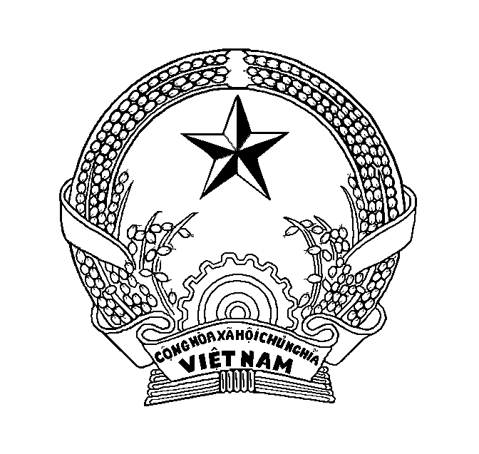

EMBASSY
of the Socialist Republic of Vietnam
in the State of Qatar

APPLICATION FOR A VIETNAMESE VISA

1. Full name (in block letters):

Photo
4x6cm

Other name (if any):
2. Date of birth (day, month, year): Sex: Male Female
3. Place of birth:
4. Nationality at birth: Nationality at present:
5. Religion:
6. Occupation: Business address:
7. Residential address:
.......................................................................Telephone:
8. Family member:
Relationship | Full name | Date of birth | Nationality | Residential address
Father
Mother
Spouse
Children
Children

9. Passport/ Document in lieu of a passport number:
Type of passport:
Issuing authority: Expiry date (day, month, year):
10.Date of the latest entry into Viet Nam (if any):
11. Proposed date of entry (day, month, year):
Proposed length of stay in Viet Nam: days
12. Purpose of entry:
13. Sponsoring, inviting organization or individual in Viet Nam (if any):
Name of sponsoring; inviting organization:
Address:
Sponsoring, inviting individual (full name)
Address:

Relationship to the applicant:
14. Accompanying child(ren) under 14 years old (if any)
(2 photographs 4x6cm)

Photo
4x6cm

Photo
4x6cm

 | Full name | Date of birth | Nationality | Passport No | Relationship to the applicant

15. Entries requested: single multiple .
(If the length of stay in Viet Nam is LESS than 16 days, choose only single)
16. Other relevant requests (if any):

17. Mobile phone:
18. Email:
I swear that the above declarations are true and correct to the best of my knowledge and belief.
Place and date (day, month, year) of the application:
Signature and full name of applicant:

Notes:
- Applications should include a photocopy of return tickets and valid Qatar ID, having at least 1000 USD when arriving Vietnam. Bank statement (until the date of application) is required.
- Applicant should have a letter from the company which he/she works for.
- From Vietnam, if applicants visit third country, visas for that country should be available. Without such visas, applicants are required to prove that the visas are exempted or issued on arrival. If exempted, Embassy of Vietnam will give applicants a certificate of endorsement so that applicants will show immigration officials this paper when they arrive in Vietnam.
- Each person completes one form and attaches a recent (4x6) photo with straight forward face, without hat or sunglasses.
- If you have a passport, please modify its type such as Ordinary, Official or Diplomatic; for a documents in lieu of passport, write down its name.

